**Microchip University**

To update header double click. Hit ESC after you have made your changes

**Lab Manual for *Adding Multimeter Click to WBZ451 AnyCloud Example***

Table of Contents

**Introduction:** 2

**Prerequisites:** 2

Lab 1 – Connect Device to Azure 3

Lab 2 – Add Sensors to Device 4

Lab 3 – Modify the IoT Central Application 27

Lab 4 – Extend the IoT Central Application 41



## **Introduction:**

You will learn how to modify both the device firmware and the corresponding IoT Central application(s) to incorporate additional telemetry into the existing OOB WBZ451 Curiosity Board AnyCloudTM example.

**Required Hardware Tools:**

* [WFI32-IoT Development Board](https://www.microchip.com/en-us/development-tool/ev36w50a) (Part No. EV36W50A)
* [WBZ451 Curiosity Board](https://www.microchip.com/en-us/development-tool/EV96B94A) (Part No. EV96B94A)
* [Multimeter Click](https://www.mikroe.com/multimeter-click) (Part No. MIKROE-3116)
* [mikroBUS Xplained Pro](https://www.microchip.com/en-us/development-tool/ATMBUSADAPTER-XPRO) (Part No. ATMBUSADAPTER-XPRO)
* [XPRO-Adapter Click](https://www.mikroe.com/xpro-adapter-click) (Part No. MIKROE-4123)
* MPLAB IPE v6.05
* MPLAB X IDE v6.05
* MPLAB® XC32 Compiler v4.20
* [Terminal emulator](https://en.wikipedia.org/wiki/Terminal_emulator) software (e.g. Tera Term)

**Upon completion, you will:**

* Connect the WBZ451 Curiosity Board to your own Azure IoT Central application using a WFI32-IoT Development Board as the UART-to-Cloud serial bridge
* Add new sensors (via Multimeter Click) to the WBZ451 Curiosity Board
* Implement a new Digital Twins Model Interface (DTMI) to enable the new telemetry to be communicated to the IoT Central application
* Create a dashboard in the IoT Central application to visualize the telemetry data reported by the new sensors
* Extend the IoT Central application to manage devices at scale by creating analytics queries, running jobs, and setting rules

# Lab 1 – Set up the AnyCloudTM OOB Demo for the WBZ451 Curiosity Board as the Host MCU

**Purpose:**

Verify that the WBZ451 Curiosity Board can successfully connect to Microsoft Azure through the WFI32-IoT Development Board (which has been programmed with AnyCloudTM firmware)

**Overview:**

In this exercise we will provision the WFI32-IoT Development Board with the latest release of the AnyCloudTM firmware to serve as the “UART-to-Cloud” serial bridge. The WBZ451 Curiosity Board will be programmed with Host MCU firmware to emulate an IoT device connecting to IoT Central.

**Procedure:**

Complete the procedures outlined in Microchip’s Azure AnyCloud repository:

<https://github.com/MicrochipTech/AzureDemo_AnyCloud>

**Results:**

The WBZ451 Curiosity Board successfully connects to IoT Central and reports its own light and temperature sensor values to the Cloud application.

**Summary:**

By completing this lab exercise, you will have verified that the Azure AnyCloudTM firmware and corresponding example OOB demo application works with your hardware – and is now ready for some additional customizations.

# Lab 2 – Add Sensors to Device

**Purpose:**

Learn how to add extra sensors to an existing device that has already successfully connected to Azure IoT Central

**Overview:**

In this exercise we will add extra sensors to an existing Azure IoT device by installing the MikroElektronika Multimeter Click board onto the WBZ451 Curiosity Board and then modifying the Plug and Play Device Twin Model Interface (DTMI) to accommodate the additional telemetry data reported by the Multimeter Click board’s sensors.

**Procedure:**

**STEP 1: Assemble the boards required to make up the IoT Device**

**Step 1a:** Install the XPRO-Adapter Click onto the WBZ451 Curiosity Board



**Step 1b:** Connect the mikroBUS Xplained Pro to the XPRO-Adapter Click



**Step 1c:** Install the Multimeter Click onto the mikroBUS Xplained Pro



**Step 1d:** Connect 3 jumper wires between the XPRO-Adapter Click & WFI32-IoT boards as shown in the following wiring diagrams

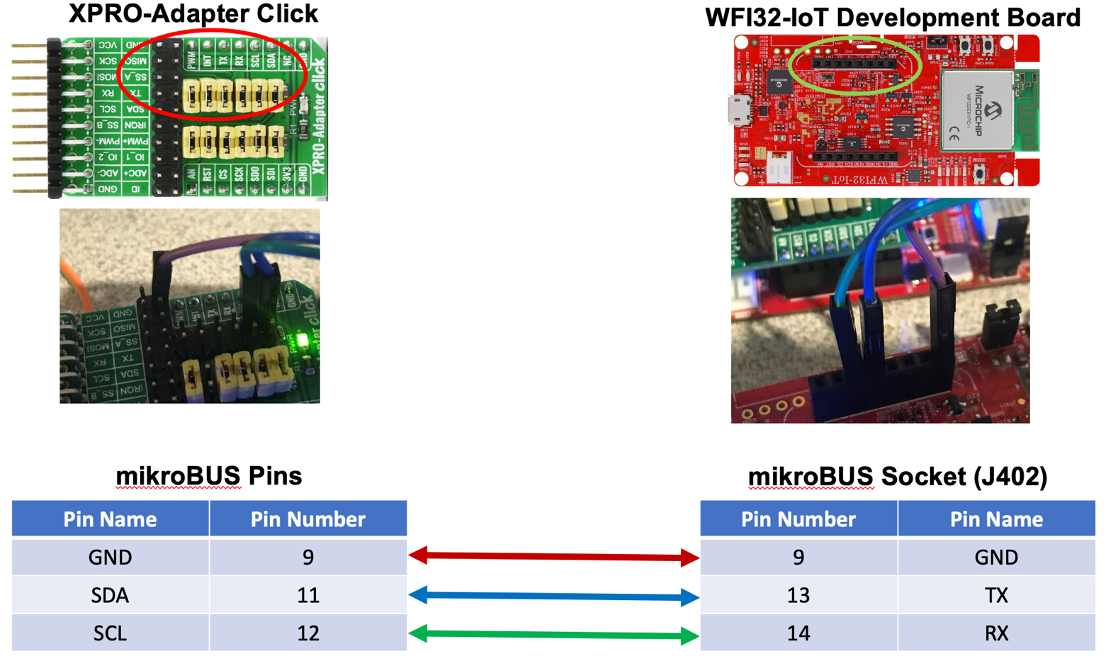

**STEP 2: Create a Working Copy of the WBZ451_AnyCloud Demo Project**

**Step 2a:** Using a File Explorer window, navigate to the \examples folder (in your clone of the **AzureDemo_AnyCloud** repository). Make a copy of the **WBZ451_AnyCloud** folder and rename it to **WBZ451_AnyCloud_Multimeter**



New renamed copy

**STEP 3: Launch the MPLAB X IDE**

**Step 3a:** If not already open, launch the MPLAB X IDE

**Step 3b:** Close any projects that are currently opened by selecting [File 🡪 Close All Projects] using the MPLAB X main toolbar

**STEP 4: Open the Newly Created Project**

**Step 4a:** From the MPLAB X main toolbar, select [File 🡪 Open Project]

**Step 4b:** Navigate to the **AzureDemo_AnyCloud\examples\WBZ451_AnyCloud_Multimeter\firmware** folder

**Step 4c:** Select (click on) the **WBZ451_AnyCloud.X** project folder

**Step 4d:** Click on the **Open Project** button



**STEP 5: Rename the Project to *WBZ451_AnyCloud_Multimeter***

**Step 5a:** In the Projects view, right-click on the **WBZ451_AnyCloud** project and select **Rename**



**Step 5b:** Check **Also Rename Project Folder** and type **WBZ451_AnyCloud_Multimeter** for the **Project Name**



**Step 5c:** Click the **Rename** button

**STEP 6: Clean and Build the Project**

**Step 6a:** Click on the **Clean and Build Main Project** icon in the MPLAB X main toolbar



CLICK

**Step 6b:** Verify that the build is successful before proceeding; otherwise review the previous steps to make sure each one has been implemented correctly. Do not proceed until the project builds successfully. If you need to refer to a working copy of the project, the solution can be found in the **\exercises\solutions\WBZ451_AnyCloud_Multimeter** folder

**STEP 7: Update the “Plug and Play” Model ID**

**Step 7a:** Open (double-click) the “IoT_Sensor_Node_config.h” header file located under [SAM-IoT_WeatherClick 🡪 Header Files 🡪 iot_config]

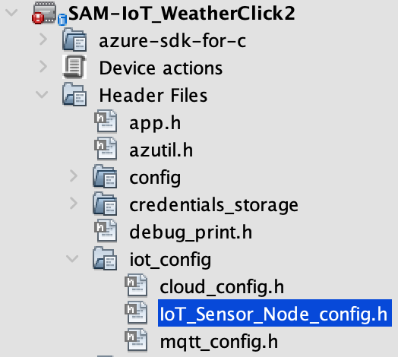

**Step 19b:** Update the **Plug and Play Model ID** to reflect the new addition of the Weather Click Board sensors

COPY

#define IOT_PLUG_AND_PLAY_MODEL_ID "dtmi:com:Microchip:SAM_IoT_Weather;1"



**STEP 22: Clean and Build the Project**

**Step 22a:** Click on the **Clean and Build Main Project** icon in the MPLAB X main toolbar

CLICK



**Step 22b:** Verify that the build is successful before proceeding; otherwise review the previous steps (after the last successful build) to make sure each one has been implemented correctly. You will not be able to proceed with programming the board until the project builds successfully. If you need to refer to a working copy of the project, the solution can be found in the **\Labs\solutions\Microchip-SAM-IoT-Wx-Weather** folder.

**NOTE:** If you are still stuck after multiple attempts to correct your project, you can close your current project and then load the working project found in the solutions folder (configure the project’s settings as you did in the beginning of this lab exercise). If you are still unable to successfully build both your project and the working project from the solutions folder, simply drag and drop (i.e. copy) the **\Labs\solutions\SAM-IoT_Weather.hex** file to the CURIOSITY drive to complete this lab exercise (i.e. skip the remaining steps).

**STEP 23: Program the Device**

**Step 23a:** Click on the **Make and Program Device Main Project** icon in the MPLAB X main toolbar



CLICK

**Step 23b:** Verify that the programming phase was successful



**Results:**

You have made numerous changes to the embedded project required to add an I2C Weather Sensor and send this new data to Azure. The following 4 tasks were accomplished:

1. Added the I2C driver code for SERCOM1 into the project. SERCOM1 was utilized because it is connected to the mikroBUS I2C pins on the SAM-IoT board.  Several code updates were required for this task, including adding in the SERCOM1 initialization code to the list of initialized peripherals, enabling its interrupt, defining its clock source, and allocating physical port pins to the module
2. Added the Weather Click driver into the project and called its initialization code in the main() function
3. Updated the model ID in the embedded project. This allows us to create a new device template in Azure, which will define our updated interfaces (adding the new sensors)
4. Updated the functions that build and send telemetry messages, so that they can read the Weather Click data and report the information to Azure

After the SAM-IoT WG Development Board has been programmed with the updated project, it should reset and then go through its normal Wi-Fi and Cloud connection phases. Confirm that ***both*** the Blue and Green LEDs on the SAM-IoT board are solidly on which signifies that the board has connected to Wi-Fi and the Cloud.

**Summary:**

At this point, your board can successfully connect to Azure IoT Central using the newly-updated device model interface. Now it’s time to modify the IoT Central application to display the additional telemetry being reported by the Weather Click board’s temperature, humidity, and pressure sensors.

# Lab 3 – Modify the IoT Central Application

**Purpose:**

Learn how to add a device template to an IoT Central application.

**Overview:**

In this exercise we will create a new device template in the existing IoT Central application so that all devices that have the updated Plug and Play model interface will be able to visually present its data on a dashboard. Upon successful completion of the lab exercise, you should see each of the Weather Click board’s sensors (humidity, pressure, and temperature) get updated periodically in a Last Known Value (LKV) tile that has been added to a new dashboard in the IoT Central application.

**Procedure:**

**STEP 1: Sign into the IoT Central Demo Application**

**Step 1a:** Go to <https://apps.azureiotcentral.com/home> and click on **My apps**



CLICK

**Step 1b:** Click on the name of the demo application which was created back in Lab 1

**STEP 2: Create the Device Template for the New Weather Click Plug and Play Model**

**Step 2a:** Using the navigation pane on the left-hand side, select [**Connect** 🡪 **Device templates**]



CLICK

**Step 2b:** Click [+ New]

CLICK

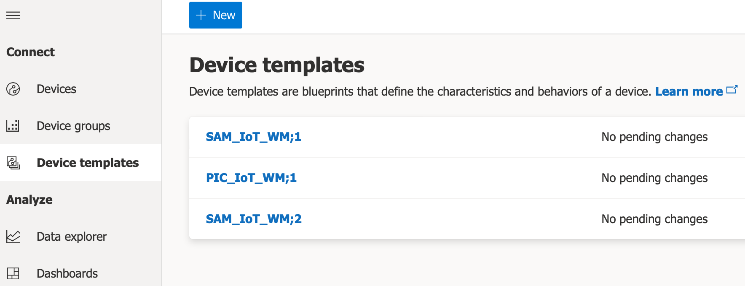

**Step 2c:** Click [IoT device]

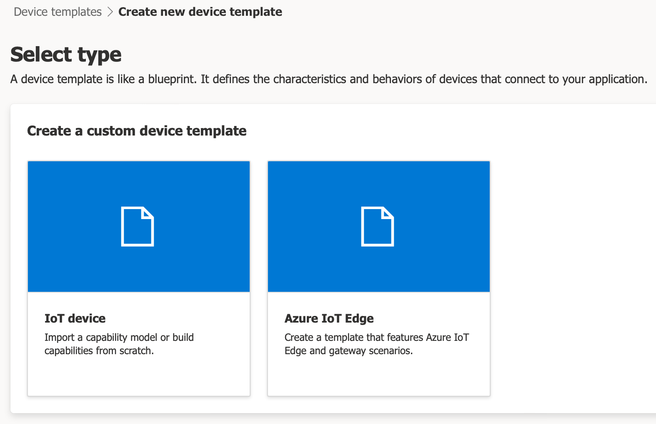

CLICK

**Step 2d:** Click [Next: Customize]



**Step 2e:** Set Device template name to **SAM_IoT_Weather;1**

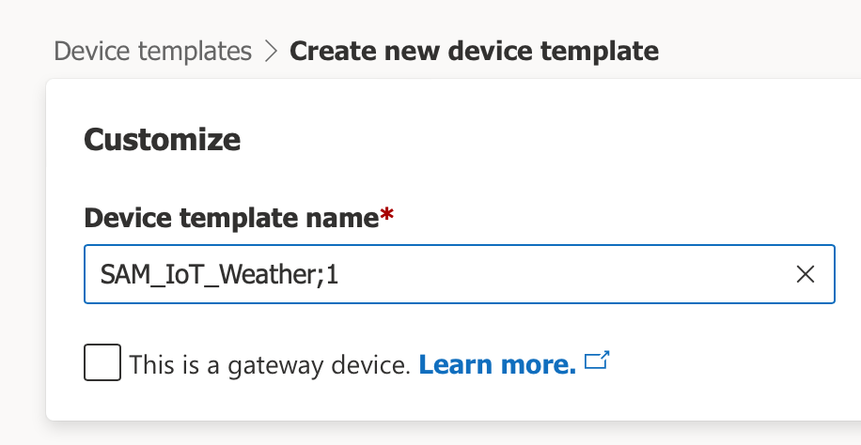

**Step 2f:** Click the **Next: Review** button



**Step 2g:** Click the **Create** button

Note the text in the graphic below is readable (not much smaller than 12 point). Also highlight buttons or boxes students need to interact with.

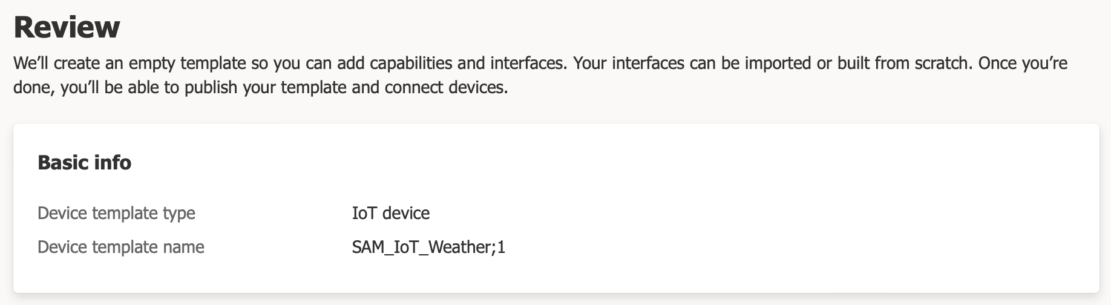



**Step 2h:** Click the **Import a model** tile

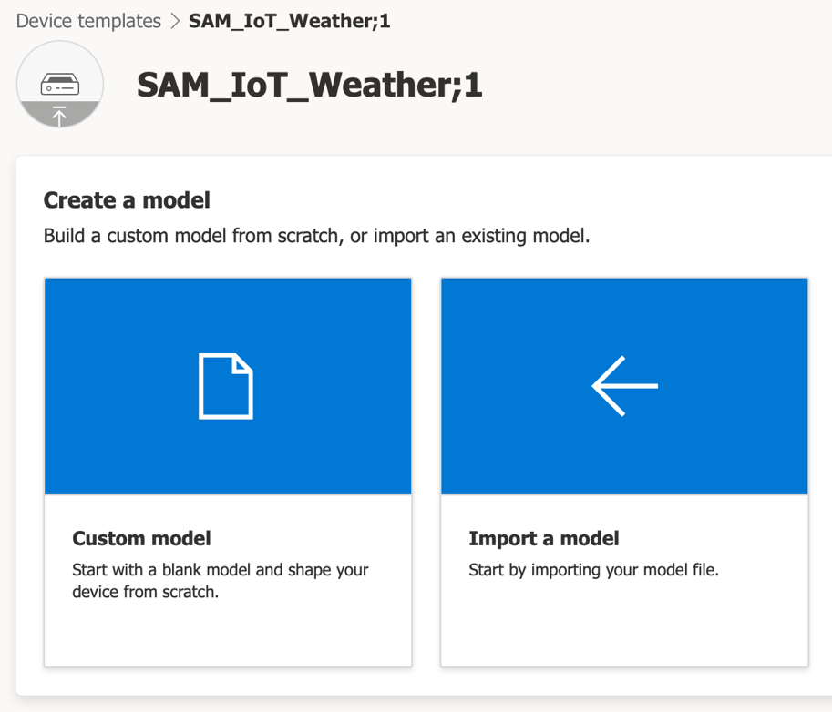

CLICK

**Step 2i:** Select “sam_iot_weather-1.json” (located in **\Labs\lab3**) then click **Upload**

**Step 2j:** Click on the **Views** category underneath the model name

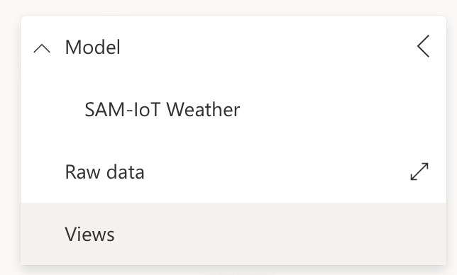

**Step 2k:** Click on the **Editing device and cloud data** tile

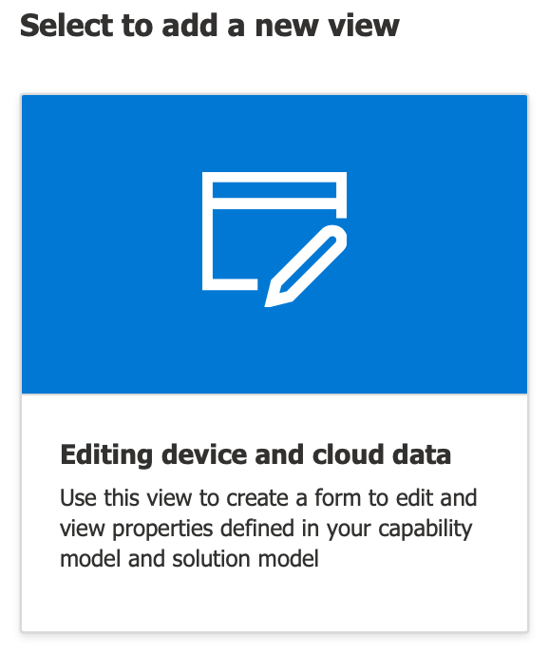

**Step 2l:** Type in **Properties** for the **Form name**



**Step 2m:** Click on the **Properties** category and check the following boxes:

* **ATWINC1510 Firmware Version**
* **Blue LED state**
* **Green LED state**
* **IP Address**
* **Red LED state**
* **Set Telemetry Interval**
* **Yellow LED state**

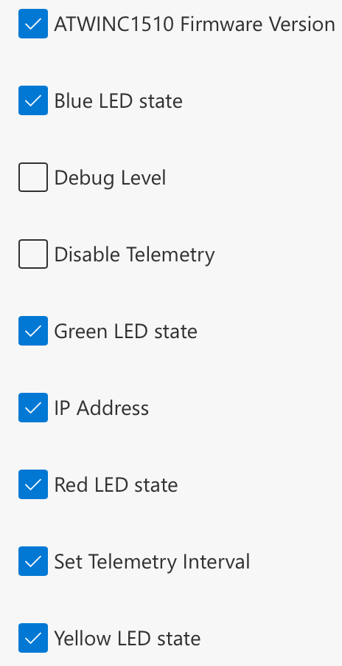

**Step 2n:** Click on the **Add section** button (bottom of the page), click on the **Save** icon (top of the page), and then click on the **Back** button

**Step 2o:** Click on the **Views** category underneath the device model name

**Step 2p:** Click on the **Generate Default Views** tile

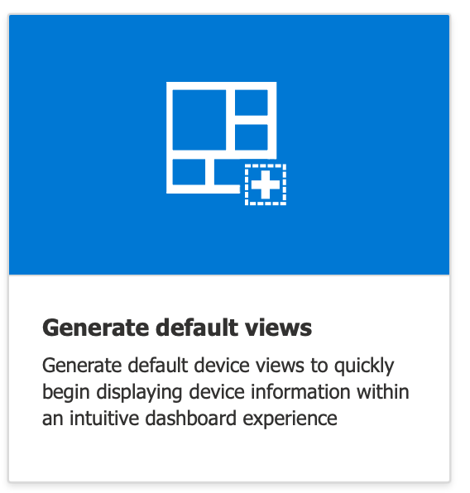

**Step 2q:** Click on the **Generate default dashboard view(s)** button



**Step 2r:** Click on the **Publish** icon at the top of the page

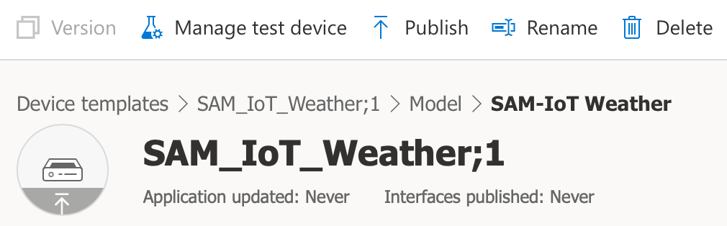

**Step 2s:** Click on the **Publish** button



CLICK

**STEP 3: View and Update the Properties of your Device**

**Step 3a:** Using the navigation pane on the far left-hand side of the page, click on [**Connect** 🡪 **Devices**]



CLICK

**Step 3b:** Click on your device name

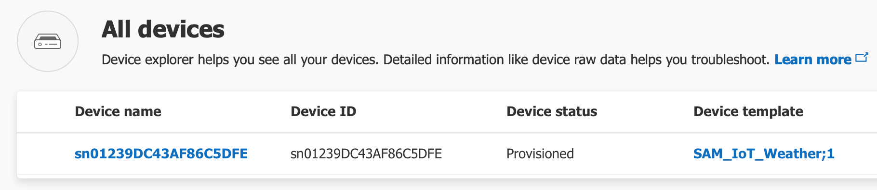

**Step 3c:** Click on the **Properties** tab

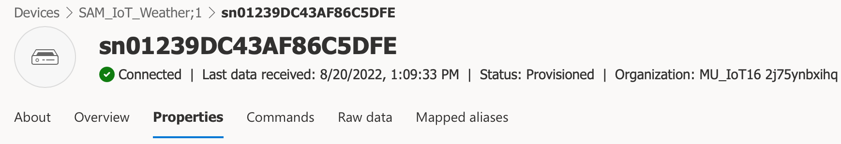

**Step 3d:** Scroll down to the **Yellow LED state** property and select **LED Blinking**

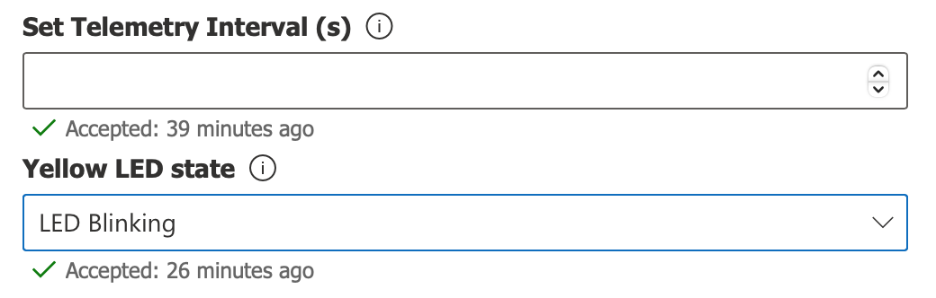

**Step 3e:** Scroll towards the top of the page and hit the **Save** icon

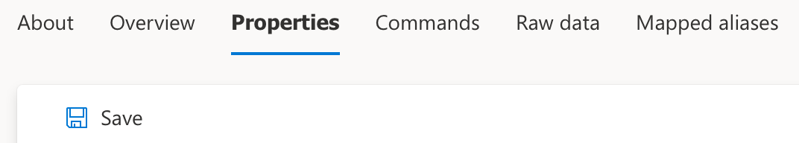

CLICK

**Step 3f:** Confirm that the Yellow LED on the SAM-IoT WG Development Board is blinking

**Step 3g:** Scroll down towards the bottom of the page to update the telemetry interval to a lower value which results in a higher frequency (e.g. 2 seconds)

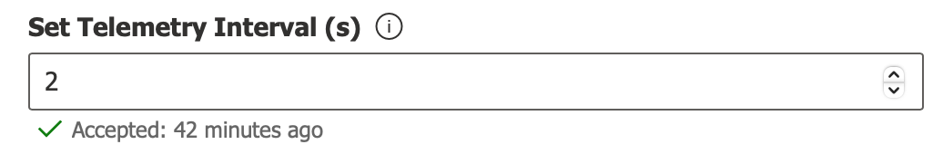

**Step 3h:** Scroll towards the top of the page and hit the **Save** icon

**Step 3i:** Click on the **Raw data** tab and confirm that a telemetry message is being received approximately every 2 seconds

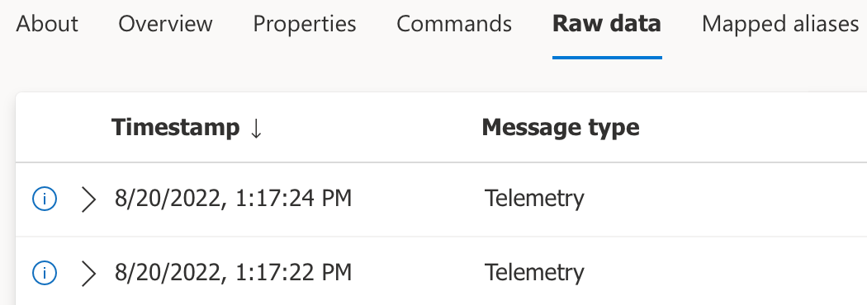

CLICK

**Step 3j:** Click on the **About** tab for a convenient way of viewing of all the device properties at once

CLICK

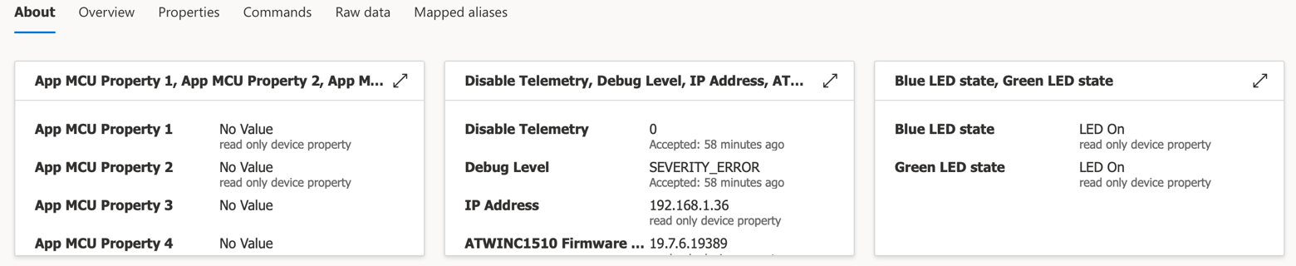

**STEP 4: Create a New Dashboard to Display the Weather Click Sensor Values**

**Step 4a:** Using the navigation pane on the far left-hand side of the page, click on [**Analyze** 🡪 **Dashboards**]



CLICK

**Step 4b:** Click on the **Go to dashboard catalog** icon

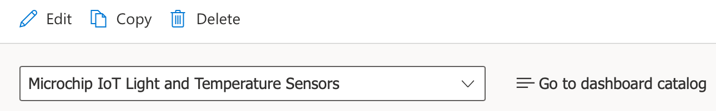

CLICK

**Step 4c:** Click the **+ New** button

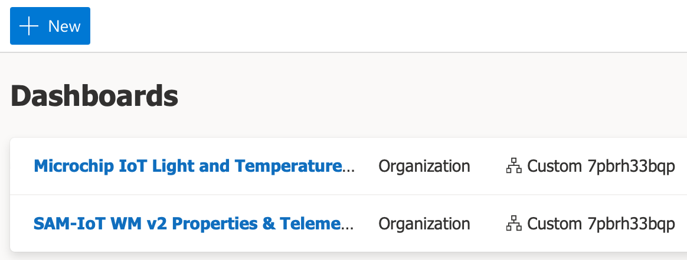

**Step 4d:** Type **SAM-IoT Weather Click** for the **Name**

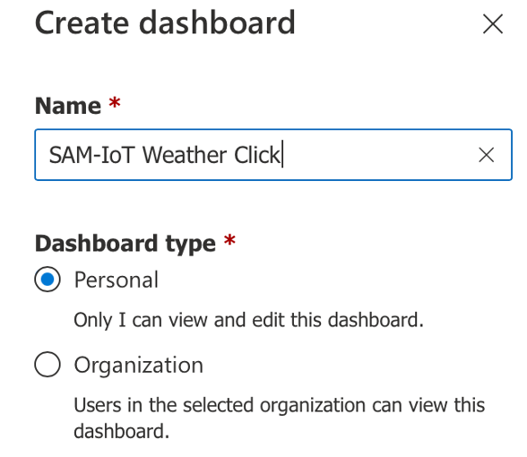

**Step 4e:** Click the **Edit** icon

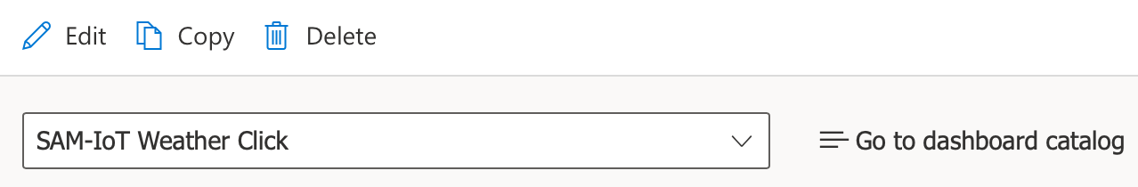

CLICK

**Step 4f:** Drag the **Last known value (LKV)** tile onto the canvas

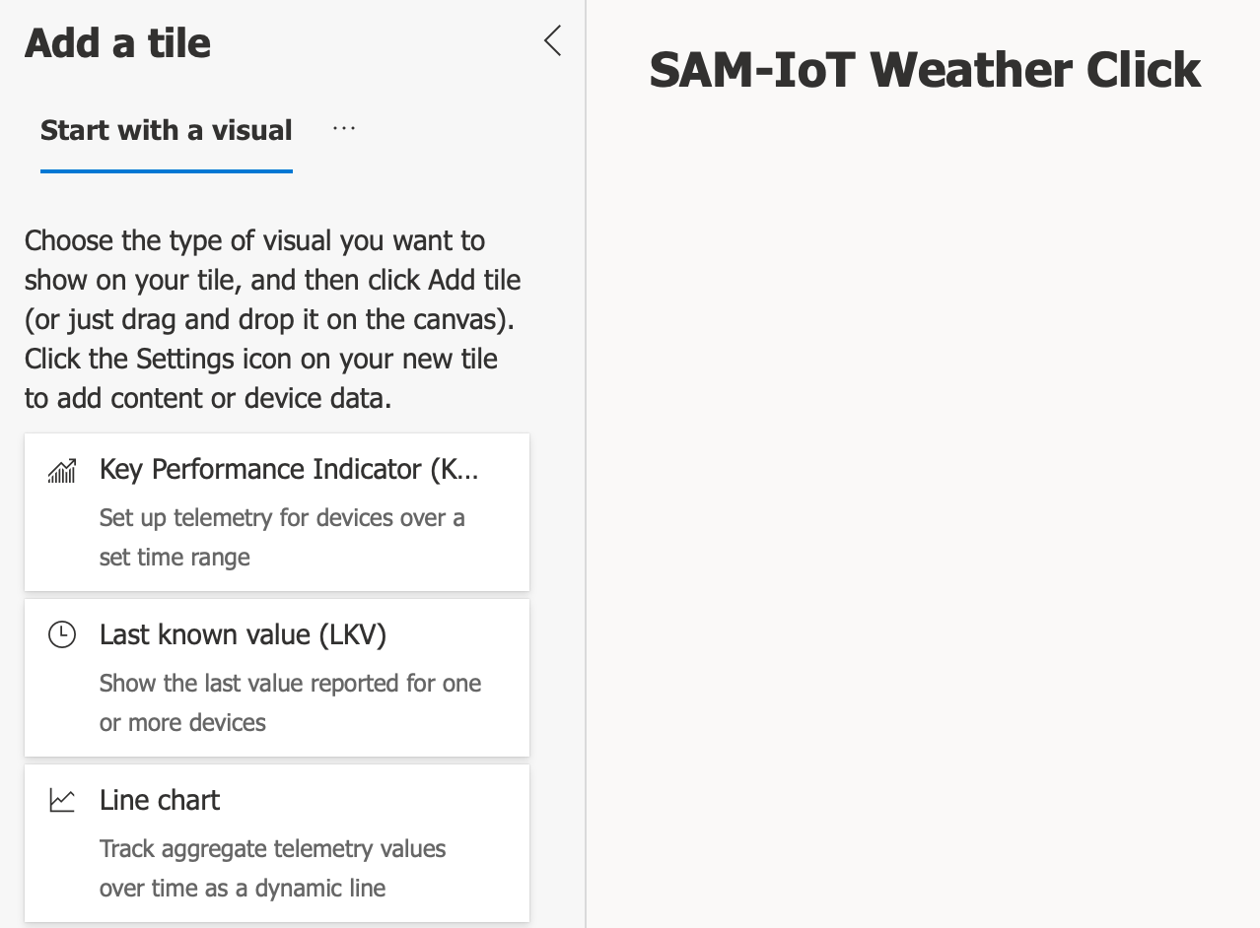

Drag and Drop

**Step 4g:** Click the **Edit** icon in the upper right-hand corner of the LKV tile

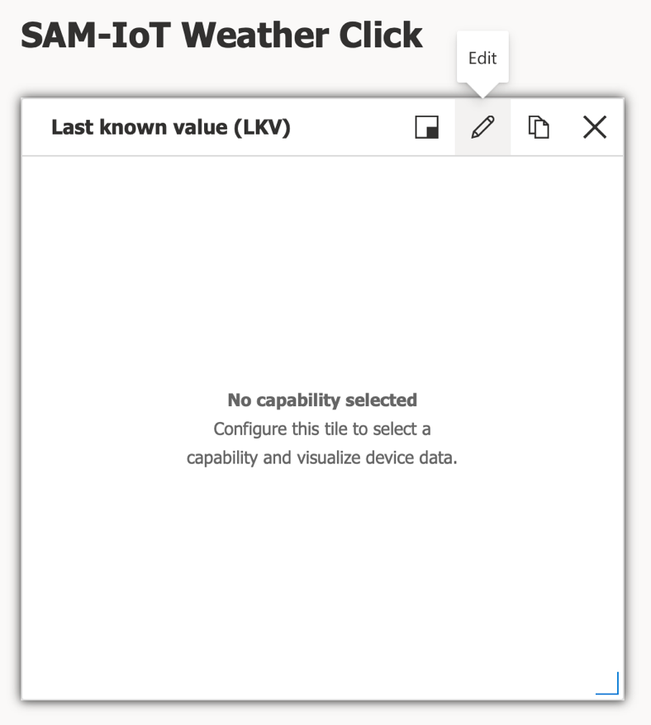

**Step 4h:** Select **SAM_IoT_Weather;1** for **Device group**

**Step 4i:** Select your device name under **Devices**

**Step 4j:** Click on **+Capability** (a total of 3 times) to add the telemetry for the Weather Click sensors

**Step 4k:** Click the **Update** button to finalize the edits to the tile

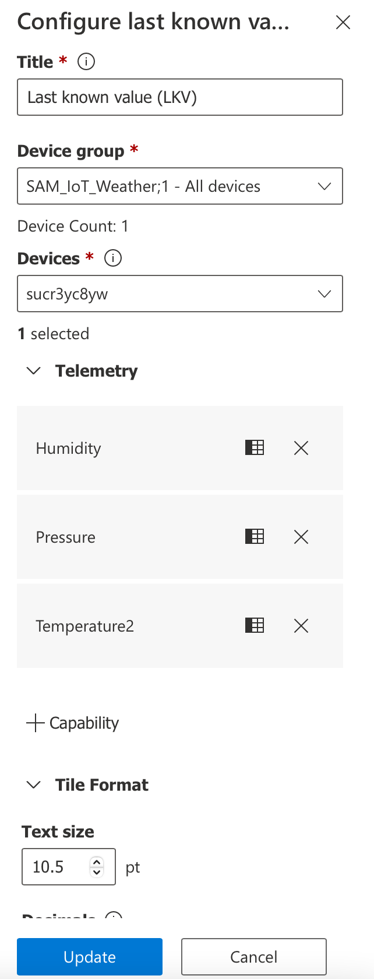

**Step 4l:** Click the **Save** icon

CLICK



**Results:**

Humidity, Pressure, and Temperature2 should all show reasonable values for the Weather Click

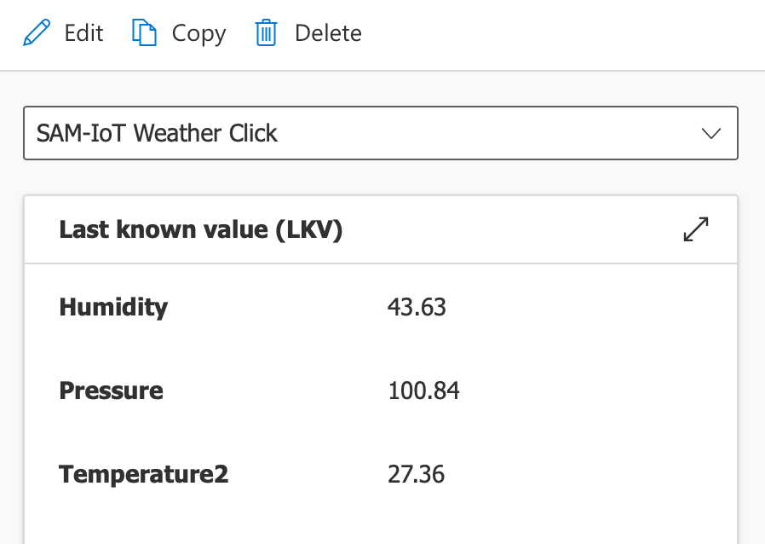

**Summary:**

In this exercise, we added a new device template to the existing IoT Central application so that the device with the updated Plug and Play model interface was able to report the Weather Click board telemetry.

# Lab 4 – Extend the IoT Central Application

**Purpose:**

Learn how to leverage some of the extended features offered by IoT Central to help analyze and manage your devices at scale.

**Overview:**

In this exercise we will extend the IoT Central application beyond the visual dashboard to help us manage the devices that are currently connected to Azure. Some of these extended features include creating analytics queries, running jobs, and settings rules.

**Procedure:**

**STEP 1: Create an Analytics Query**

Azure IoT Central provides rich analytics capabilities to analyze historical trends and correlate telemetry from your devices. A query allows the IoT Central application to interrogate a device (or a group of devices) for various pieces of information. The following are examples of how you can use a query:

* Get the last sequence of telemetry values reported by a device
* Get the last 24 hours of data from devices that are in the same room
* Analyze telemetry trends from devices over a specific time frame (e.g. multiple days)

**Step 1a:** On the left-hand navigation pane under **Analyze**, select **Data explorer**



CLICK

**Step 1b:** Click on the **+ New query** button



**Step 1c:** Select the **Device group** (e.g. SAM_IoT_Weather;1)

**Step 1d:** Under **Telemetry**, select **Humidity**

**Step 1e:** Click **+Add** and select **Pressure**

**Step 1f:** Click **+Add** and select **Temperature2**

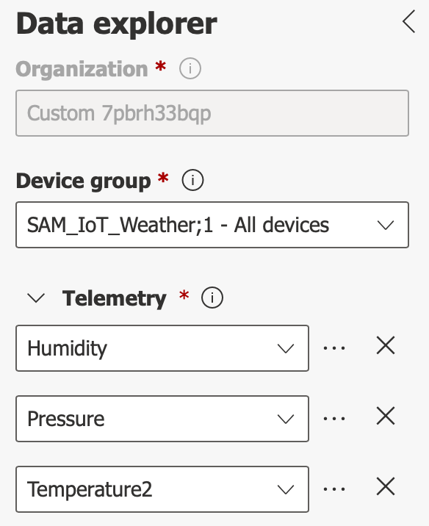

**Step 1g:** Click on the **Save** icon

CLICK



**Step 1h:** Type in a name for the query (e.g. Weather Click Telemetry)

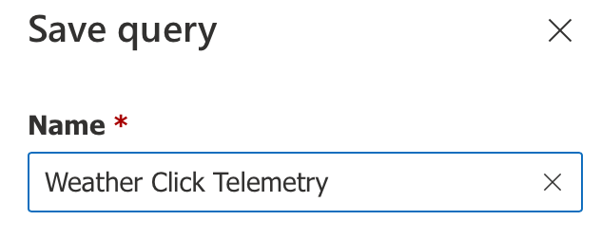

**Step 1i:** Click on the **Save** button



CLICK

**Step 1j:** Click on the various sliders and buttons to interact with your data

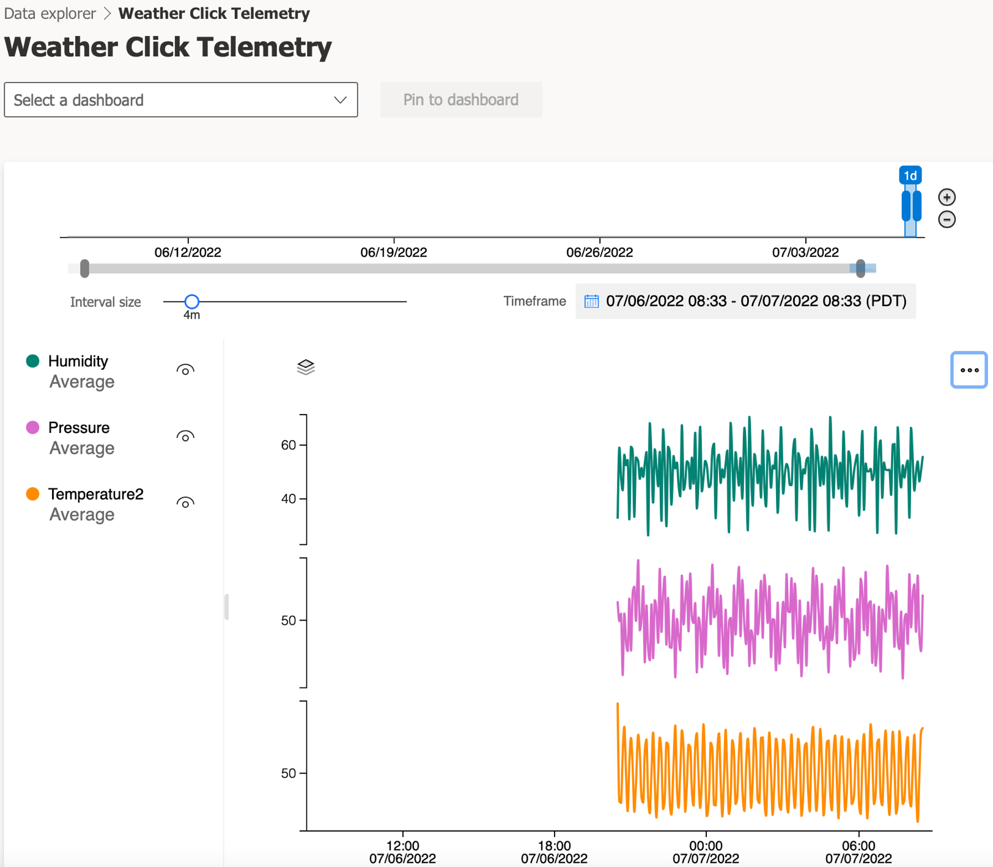

**Step 1k:** Click on the ellipsis to bring up additional functions



**Step 1l:** Click on the **Analyze** button to refresh the data

CLICK



**Step 1m:** For additional guidance on analytics queries, consult the Microsoft Azure IoT Central documentation**:** <https://docs.microsoft.com/en-us/azure/iot-central/core/howto-create-analytics>

**STEP 2: Run a Job**

You can use Azure IoT Central to manage your connected devices at scale through jobs. Jobs let you do bulk updates to device and cloud properties as well as run commands supported by the device model. You can also use CSV files to import and export devices in bulk. We will create a job and then run the job to set the state of the Yellow LED on the SAM-IoT WG Development Board to blink periodically.

**Step 2a:** On the left-hand navigation pane under **Manage**, select **Jobs**



CLICK

**Step 2b:** Click the **+ New** button

CLICK



**Step 2c:** On the **Configure your job** page, enter a name and description to identify the job you’re creating (e.g. Name = “Blink Yellow LED”)

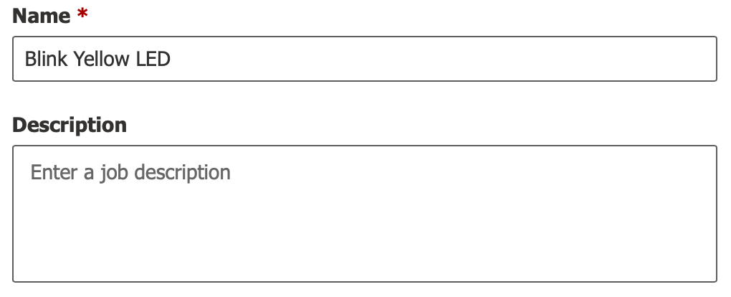

**Step 2d:** Select the target device group that you want your job to apply to (e.g. SAM_IoT_Weather;1). You can see how many devices your job configuration applies to just below the **Device group** selection

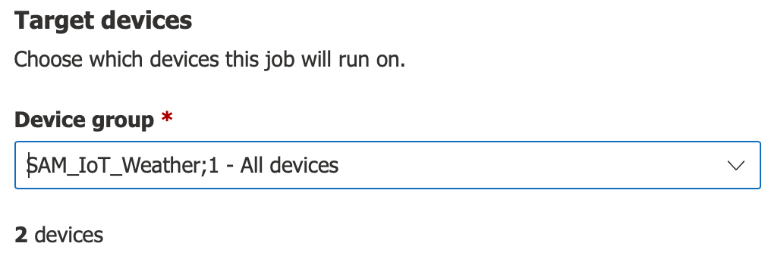

**Step 2e:** In the Job properties box, select the following:

* Job type = Property
* Name = Yellow LED state
* Value = LED Blinking

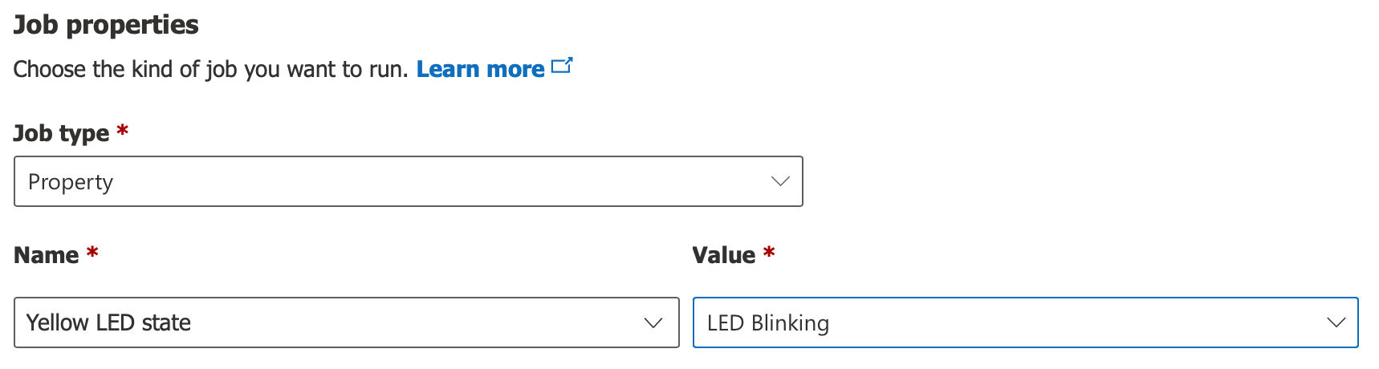

**Step 2f:** Click on **Save and exit** to add the job to the list of saved jobs on the **Jobs** page

CLICK



**Step 2g:** Click on the newly-created job in the list of **Saved** jobs

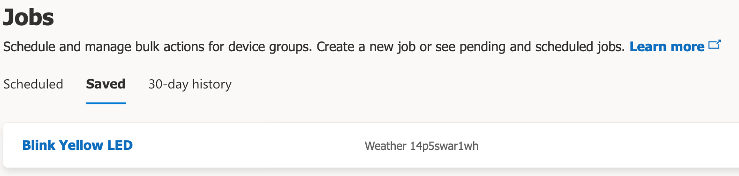

**Step 2h:** Select **Next** to move to the **Delivery Options** page. For now leave each option as Enable = Off. The Delivery Options page lets you set the delivery options for this job:

* **Batches** let you stagger jobs for large numbers of devices. The job is divided into multiple batches and each batch contains a subset of the devices. The batches are queued and run in sequence
* **Cancellation threshold** lets you automatically cancel a job if the number of errors exceeds your set limit. The threshold can apply to all the devices in the job, or to individual batches

**Step 2i:** Select **Next** to move to the **Schedule** page. This page lets you enable a schedule to run the job in the future. You can set up a job to run one time, daily, or weekly. For now leave the Schedule Enable = No

**Step 2j:** Select **Next** to move to the **Review** page. The Review page shows the job configuration details

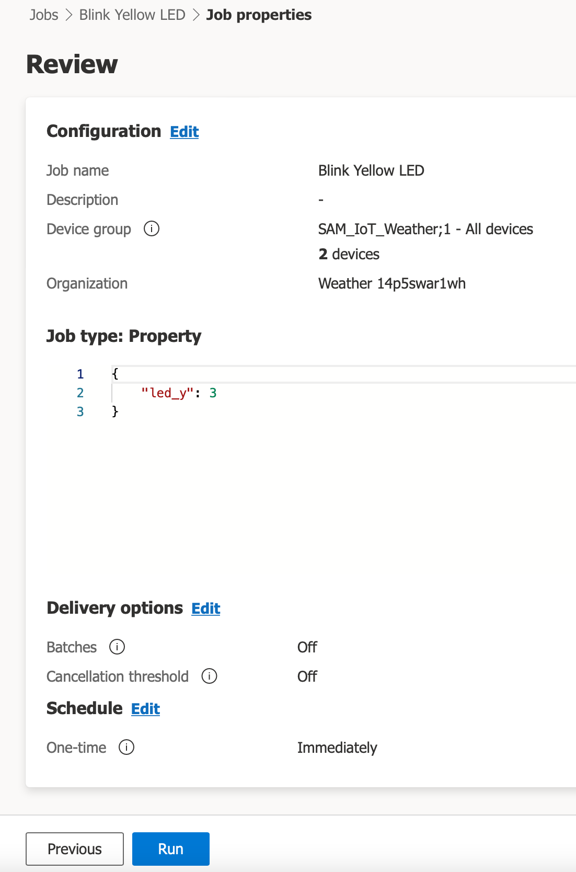

**Step 2k:** The job details page shows information about scheduled jobs. When the scheduled job executes, you see a list of the job instances. The scheduled job execution should also part of the **30-day history** job list. On this page, you can **Unschedule** the job or **Edit** the scheduled job. You can return to a scheduled job from the list of scheduled jobs.

**Step 2l:** In the job wizard, you can choose to not schedule a job, and just run it immediately. Select **Run** to run the job now

**Step 2m:** A job goes through pending, running, and completed phases. The job execution details contain result metrics, duration details, and a device list grid. When the job is complete, you can click on the **Results log** icon to download a CSV file of your job details, including the devices and their status values. This information can be useful for troubleshooting.

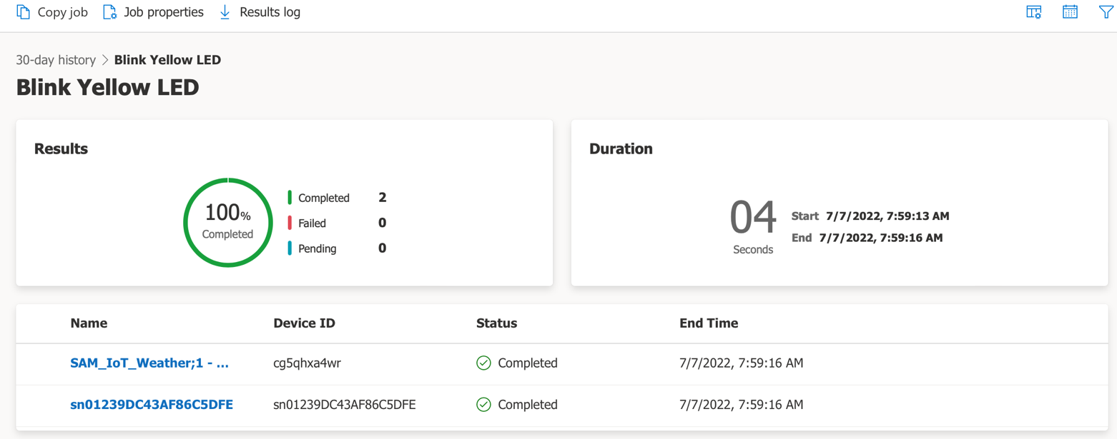

**Step 2n:** Upon completion of the job, confirm that the Yellow LED is blinking on the SAM-IoT WG Development Board

**Step 2o:** The job now appears in the **30-day history** list on the **Jobs** page. This page shows currently running jobs and the history of any previously run or saved jobs.

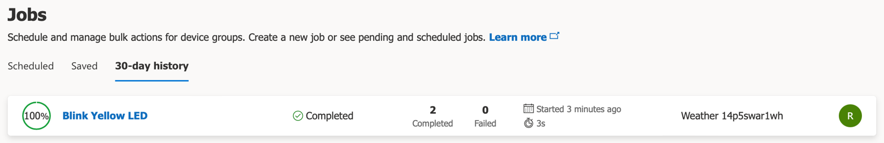

**Step 2p (Optional):** Run another job to change the Yellow LED state back to off ☺

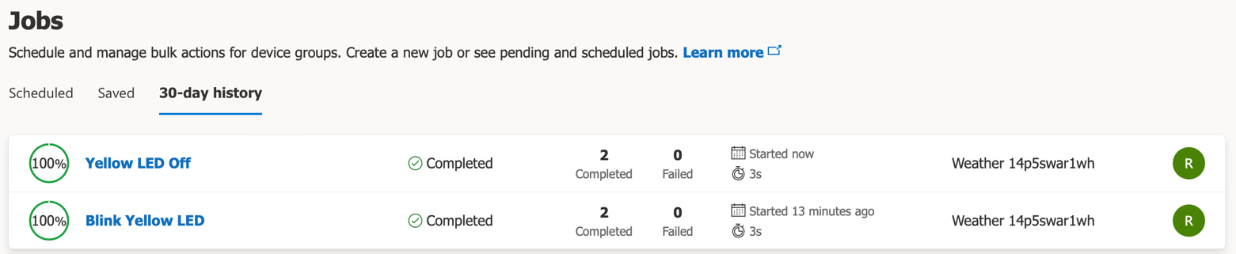

**Step 2q:** For additional guidance on managing jobs, consult the Microsoft Azure IoT Central documentation**:** <https://docs.microsoft.com/en-us/azure/iot-central/core/howto-manage-devices-in-bulk>

**STEP 3: Set a Rule**

Rules in IoT Central serve as a customizable response tool that triggers on actively monitored events from connected devices. You can define one or more actions that happen when a rule triggers. For example, when a specific condition has been detected, an e-mail message can be sent out as a response to the condition. In this step, we will set a rule that sends out an e-mail message whenever the temperature sensor of the Weather Click board surpasses the 30 degrees Celsius mark.

**Step 3a:** On the left-hand navigation pane under **Extend**, select **Rules**

**Step 3b:** Click the **+ New** button

**Step 3c:** Enter a name for the new rule (e.g. High Temp Alert)

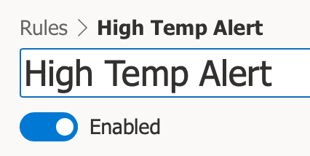

**Step 3d:** Select the Device Template (e.g. SAM_IoT_Weather;1)

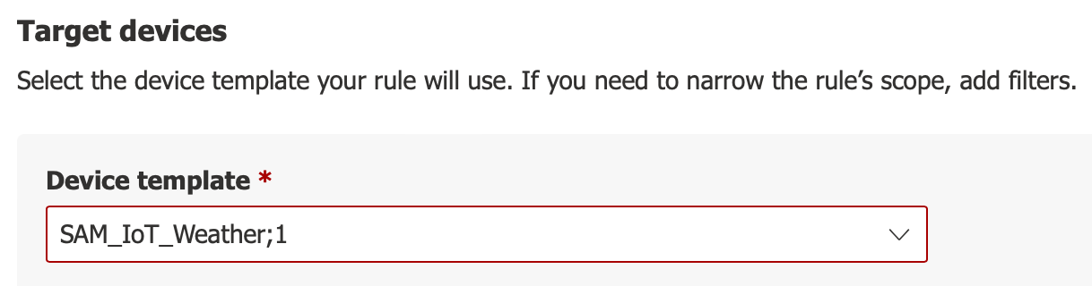

**Step 3e:** Set the conditions for generating the trigger (e.g. Weather Click board temperature sensor value, ***Temperature2***, goes above 30 degrees Celsius)

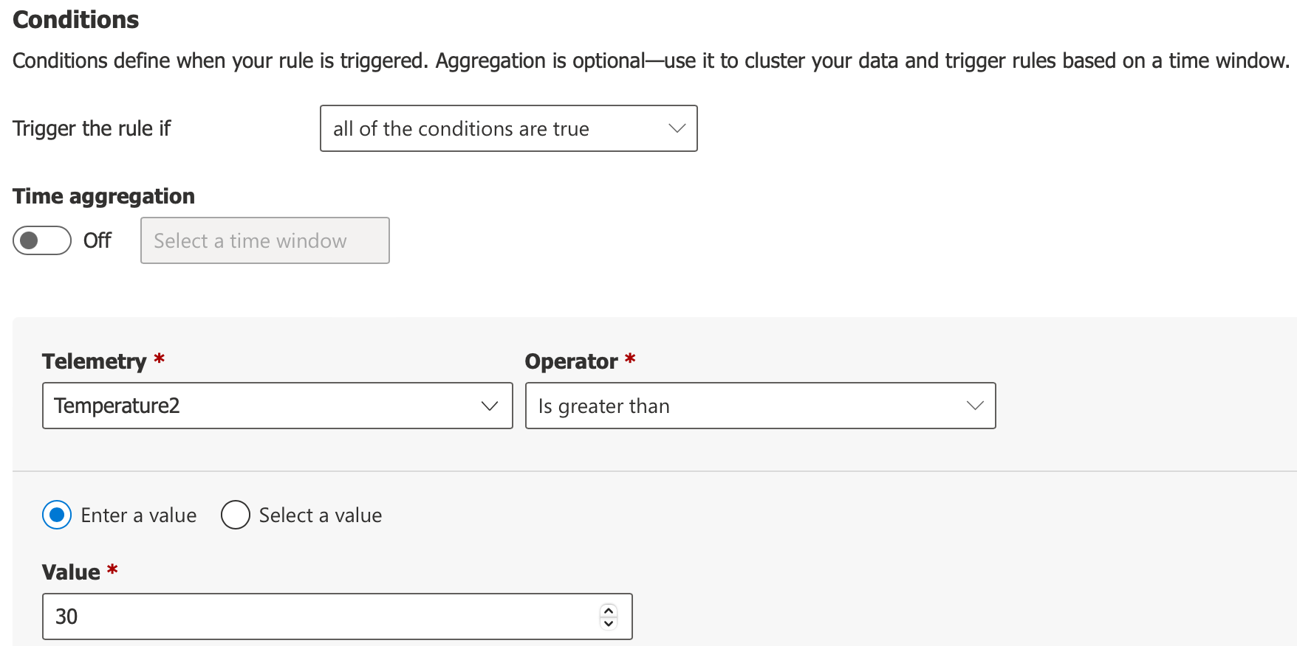

**Step 3f:** Set the appropriate action to take when triggered (click on the **+ Email** icon)

**Step 3g:** Enter the information for the e-mail message to be automatically generated

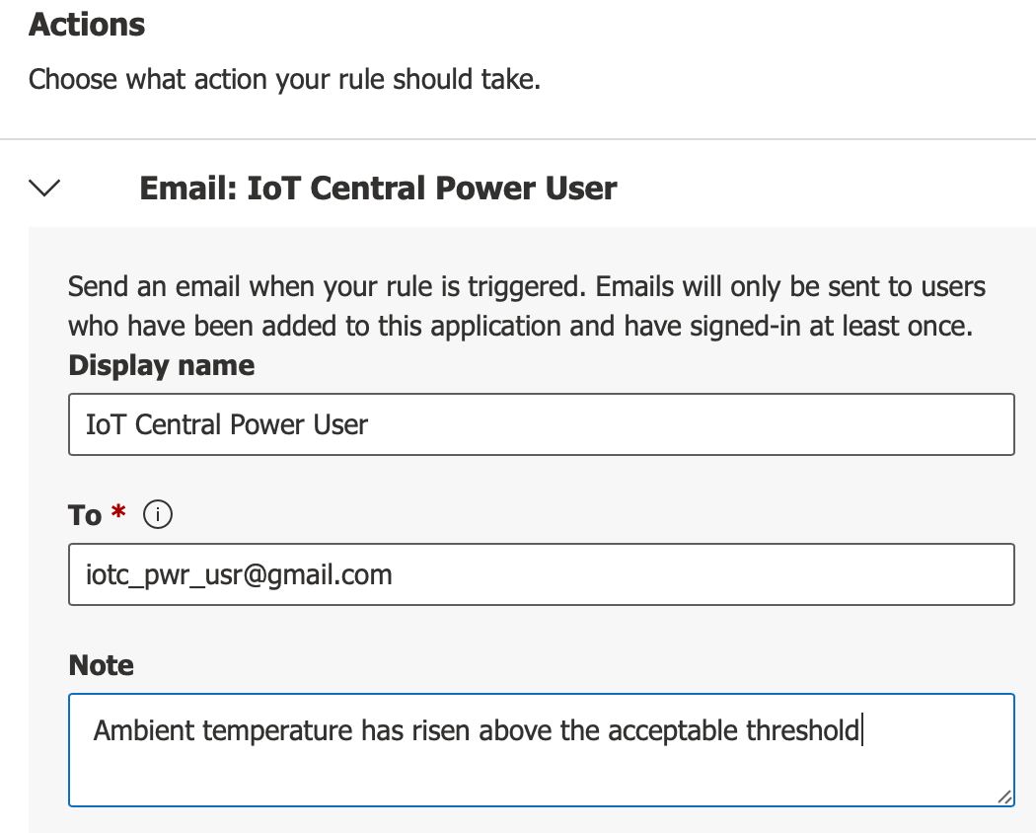

**Step 3h:** Click the **Done** button



**Step 3i:** Click the **Save** icon at the top of the page

CLICK



**Step 3j:** Using a “safe” heat source (e.g. hair dryer), warm up the Weather Click board and wait for the e-mail alert. Use the Dashboard to visually confirm that the last known value of **Temperature2** has gone above 30 degrees Celsius prior to checking for reception of the e-mail message.

**Step 3k:** For additional guidance on configuring rules, consult the Microsoft Azure IoT Central documentation: <https://docs.microsoft.com/en-us/azure/iot-central/core/howto-configure-rules>

**Results:**

In this exercise, we extended the functionality of the IoT Central application by creating an analytics query, running a job, and setting a rule.

**Summary:**

Upon conclusion of the lab exercises, we have created a successful connection between an IoT device and the Microsoft Azure cloud services. We have seen how telemetry, properties, and commands can be implemented in a sensor node and how we can harness the power of using IoT Central to monitor and manage groups of devices at scale using analytics, jobs, and rules.